Launch Ubuntu Server and install minikube

#Install VirtualBox:

sudo apt update -y

sudo apt-get install docker.io -y

systemctl start docker

sudo usermod -aG docker $(whoami)

sudo apt install virtualbox -y

sudo apt-get install conntrack -y

#Install kubectl:

sudo apt-get update && sudo apt-get install -y apt-transport-https gnupg2

curl -s https://packages.cloud.google.com/apt/doc/apt-key.gpg | sudo apt-key add -

echo "deb https://apt.kubernetes.io/ kubernetes-xenial main" | sudo tee /etc/apt/sources.list.d/kubernetes.list

sudo apt-get update

sudo apt-get install -y kubectl

#Install Minikube:

curl -Lo minikube https://storage.googleapis.com/minikube/releases/latest/minikube-linux-amd64 && chmod +x minikube && sudo mv minikube /usr/local/bin/

minikube start --kubernetes-version=v1.21.0 --driver=none

mkdir -p /opt/jenkins_home

mkdir -p /opt/keycloak

chown -R ubuntu:ubuntu /opt/jenkins_home

chown -R ubuntu:ubuntu /opt/keycloak

minikube addons enable ingress

Install Keycloak

<https://www.keycloak.org/getting-started/getting-started-kube>

create keycloak.yaml

kubectl create -f keycloak.yaml

apiVersion: v1

kind: Service

metadata:

name: keycloak

labels:

app: keycloak

spec:

ports:

- name: http

port: 8080

targetPort: 8080

selector:

app: keycloak

type: LoadBalancer

---

apiVersion: apps/v1

kind: Deployment

metadata:

name: keycloak

labels:

app: keycloak

spec:

replicas: 1

selector:

matchLabels:

app: keycloak

template:

metadata:

labels:

app: keycloak

spec:

containers:

- name: keycloak

image: quay.io/keycloak/keycloak:21.0.2

args: ["start-dev"]

env:

- name: KEYCLOAK_ADMIN

value: "admin"

- name: KEYCLOAK_ADMIN_PASSWORD

value: "admin"

- name: KC_PROXY

value: "edge"

ports:

- name: http

containerPort: 8080

readinessProbe:

httpGet:

path: /realms/master

port: 8080

Run below command to create ingress

wget -q -O - https://raw.githubusercontent.com/keycloak/keycloak-quickstarts/latest/kubernetes-examples/keycloak-ingress.yaml | \

sed "s/KEYCLOAK_HOST/keycloak.$(minikube ip).nip.io/" | \

kubectl create -f -

Enter below command:

KEYCLOAK_URL=https://keycloak.$(minikube ip).nip.io &&

echo "" &&

echo "Keycloak: $KEYCLOAK_URL" &&

echo "Keycloak Admin Console: $KEYCLOAK_URL/admin" &&

echo "Keycloak Account Console: $KEYCLOAK_URL/realms/myrealm/account" &&

echo ""

Keycloak: https://keycloak.172.31.39.79.nip.io

Keycloak Admin Console: https://keycloak.172.31.39.79.nip.io/admin

Keycloak Account Console: <https://keycloak.172.31.39.79.nip.io/realms/myrealm/account>

Once done update your /etc/hosts file in server and your laptop.

Update public Ip in laptop

13.114.230.35 keycloak.172.31.39.79.nip.io

Update Private Ip in Server

172.31.39.79 keycloak.172.31.39.79.nip.io

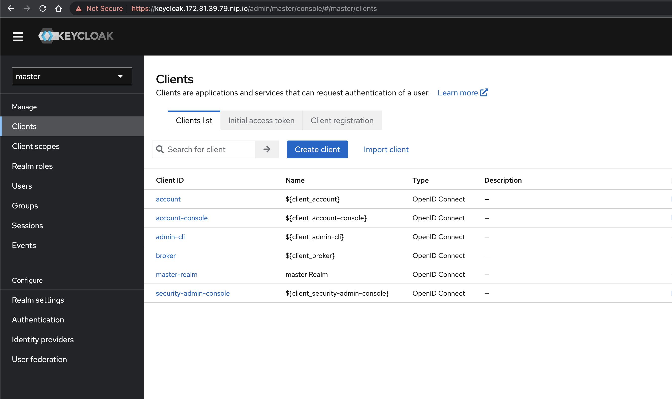

**Sample Application 1:**

**Install Jenkins**

apiVersion: v1

kind: PersistentVolume

metadata:

name: task-pv-volume

labels:

type: local

spec:

storageClassName: manual

capacity:

storage: 10Gi

accessModes:

- ReadWriteOnce

hostPath:

path: "/opt/jenkins_home"

---

apiVersion: v1

kind: PersistentVolumeClaim

metadata:

name: jenkins-pvc

spec:

storageClassName: manual

accessModes:

- ReadWriteOnce

resources:

requests:

storage: 3Gi

---

apiVersion: networking.k8s.io/v1

kind: Ingress

metadata:

name: jenkins

spec:

tls:

- hosts:

- jenkins.172.31.39.79.nip.io

rules:

- host: jenkins.172.31.39.79.nip.io

http:

paths:

- path: /

pathType: Prefix

backend:

service:

name: jenkins

port:

number: 8081

---

apiVersion: v1

kind: Service

metadata:

name: jenkins

labels:

app: jenkins

spec:

ports:

- name: http

port: 8081

targetPort: 8080

selector:

app: jenkins

type: LoadBalancer

---

apiVersion: apps/v1

kind: Deployment

metadata:

name: jenkins

spec:

replicas: 1

selector:

matchLabels:

app: jenkins

template:

metadata:

labels:

app: jenkins

spec:

containers:

- name: jenkins

image: jenkins/jenkins

ports:

- containerPort: 8080

name: http

volumeMounts:

- name: jenkins-pv

mountPath: /var/jenkins_home

- name: docker-bin

mountPath: /usr/bin/docker

- name: docker-sock

mountPath: /var/run/docker.sock

volumes:

- name: jenkins-pv

persistentVolumeClaim:

claimName: jenkins-pvc

- name: docker-bin

hostPath:

path: /usr/bin/docker

- name: docker-sock

hostPath:

path: /var/run/docker.sock

Update public Ip in laptop

13.114.230.35 jenkins.172.31.39.79.nip.io

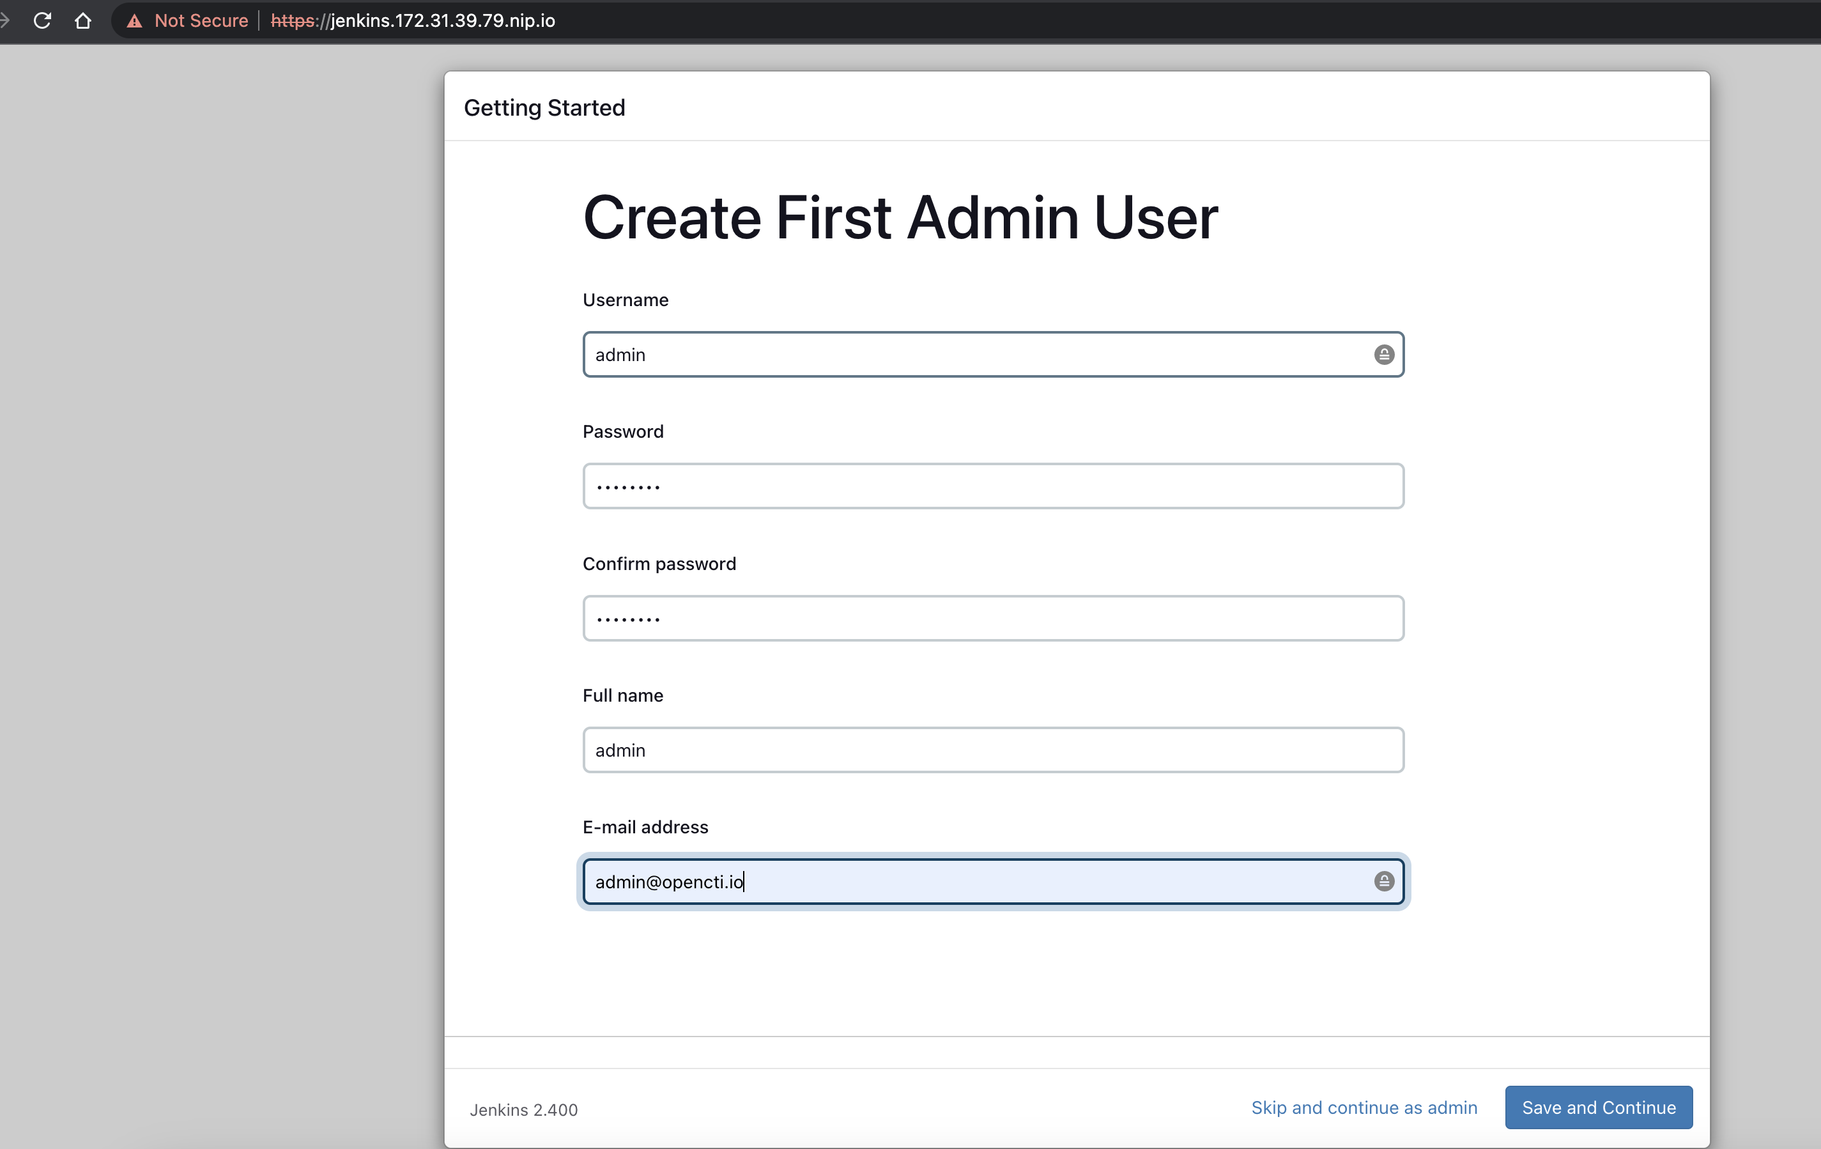

**Install SSO plugin**

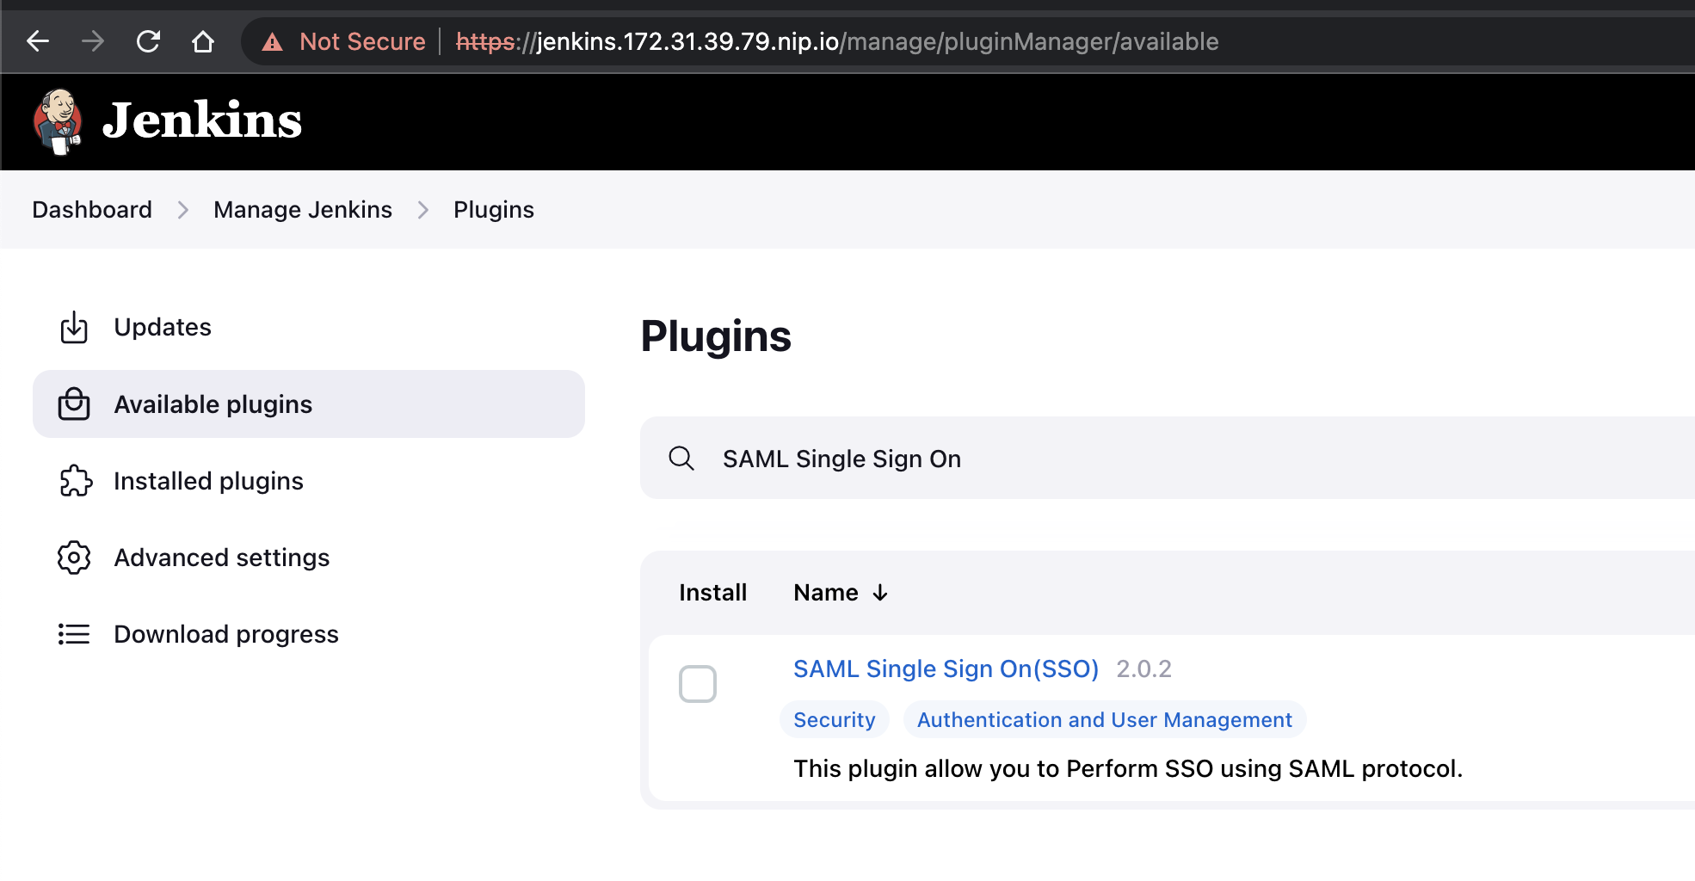

**Enable SSO**

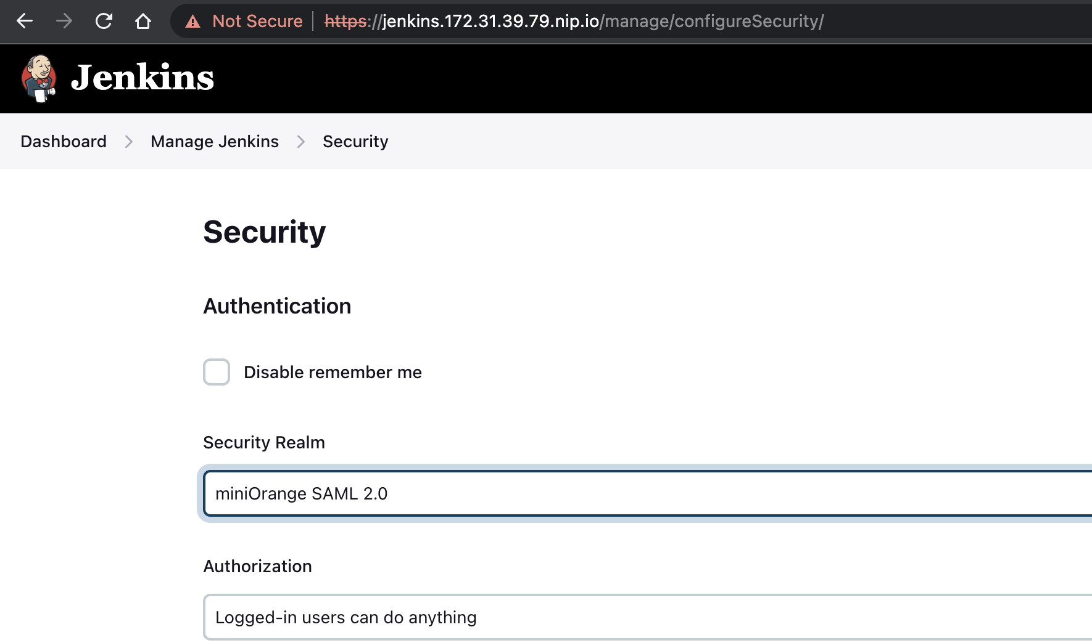

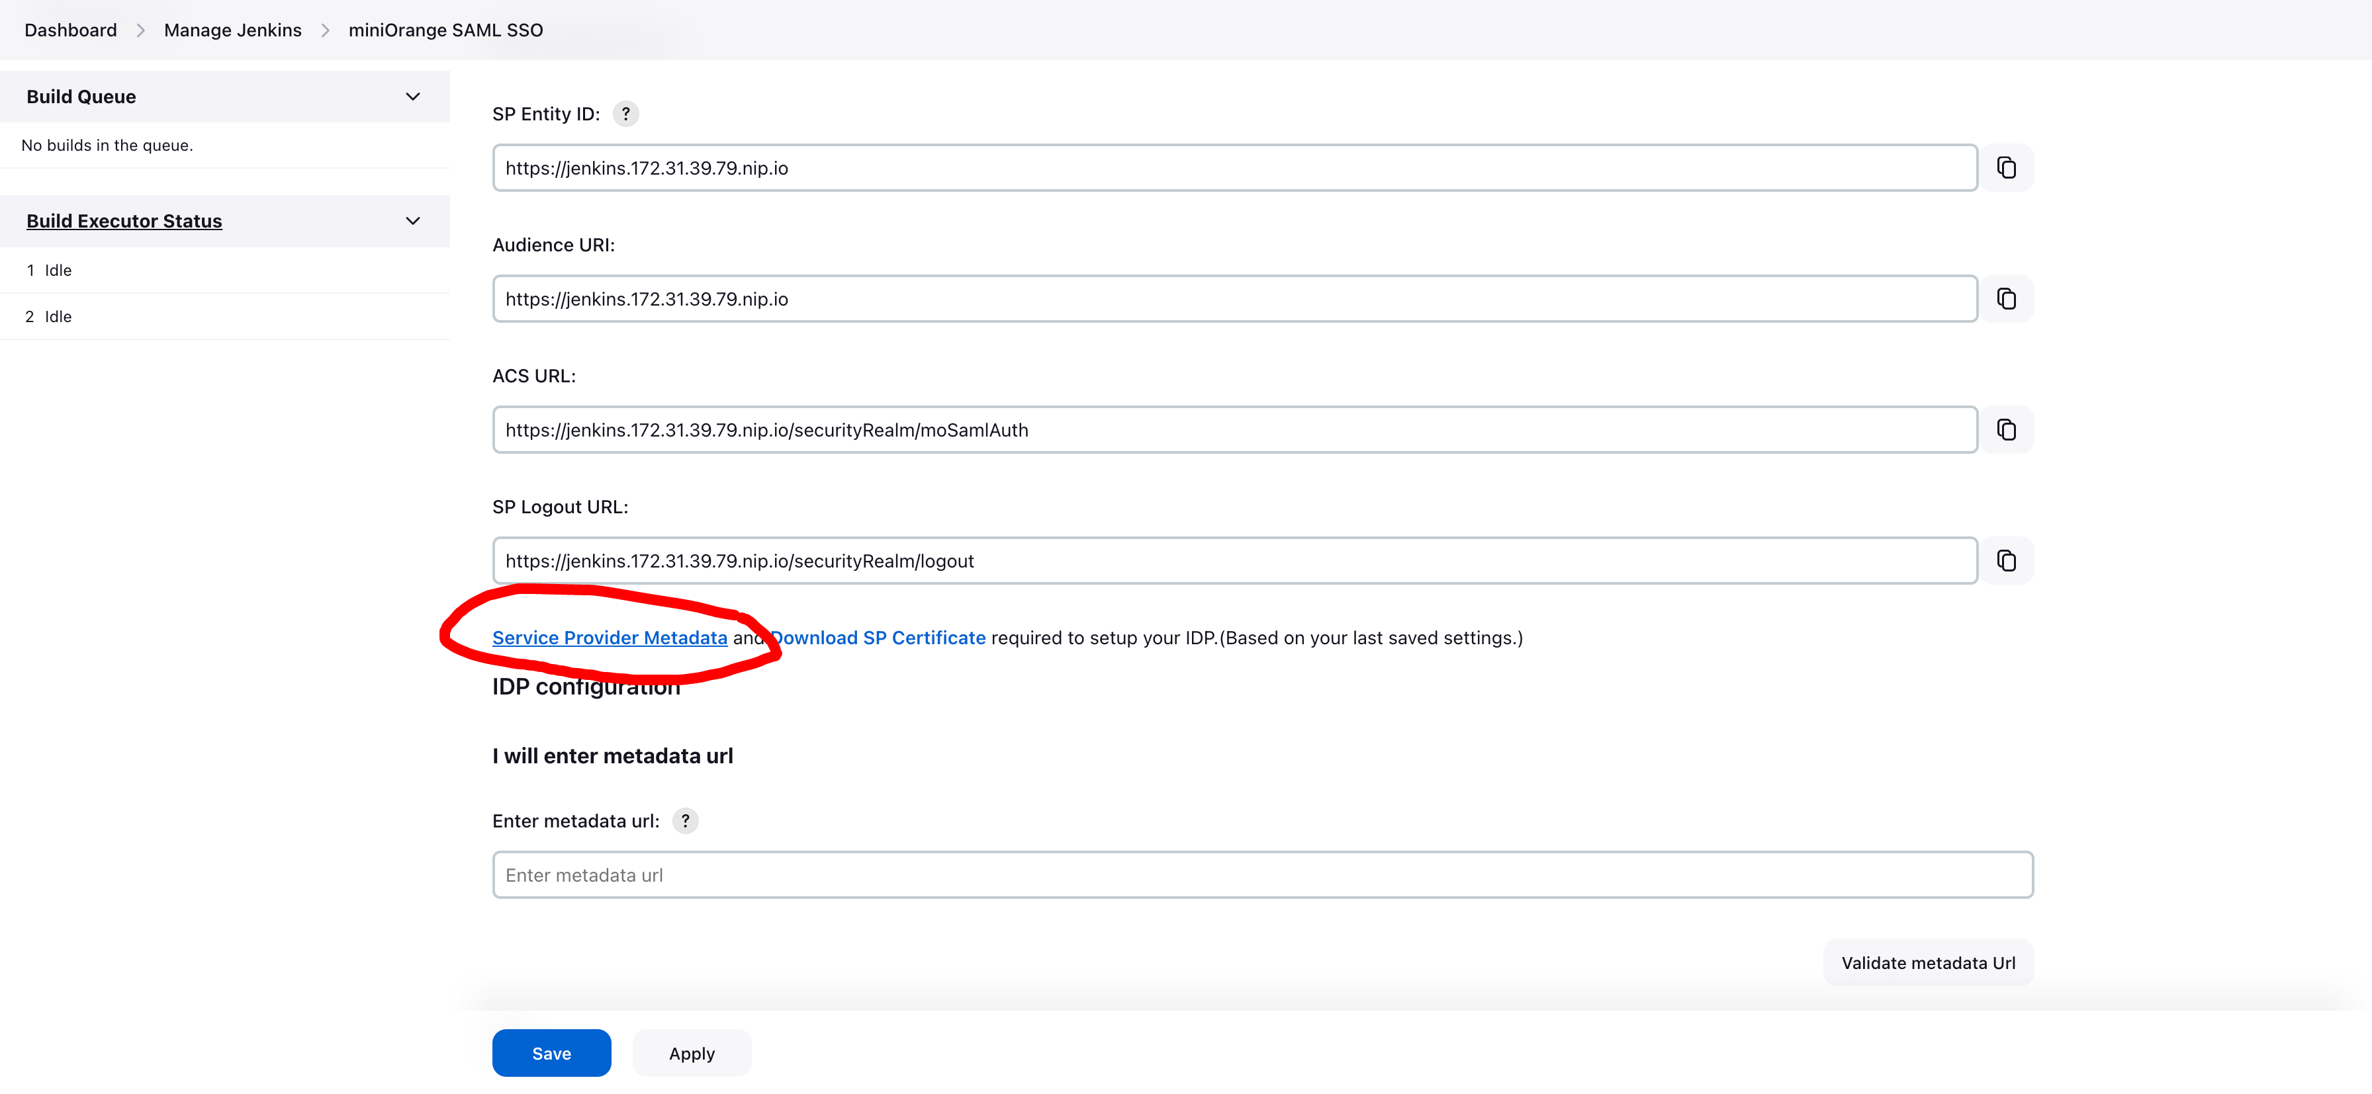

Download metadata and Import SP-metadata file in keycloak

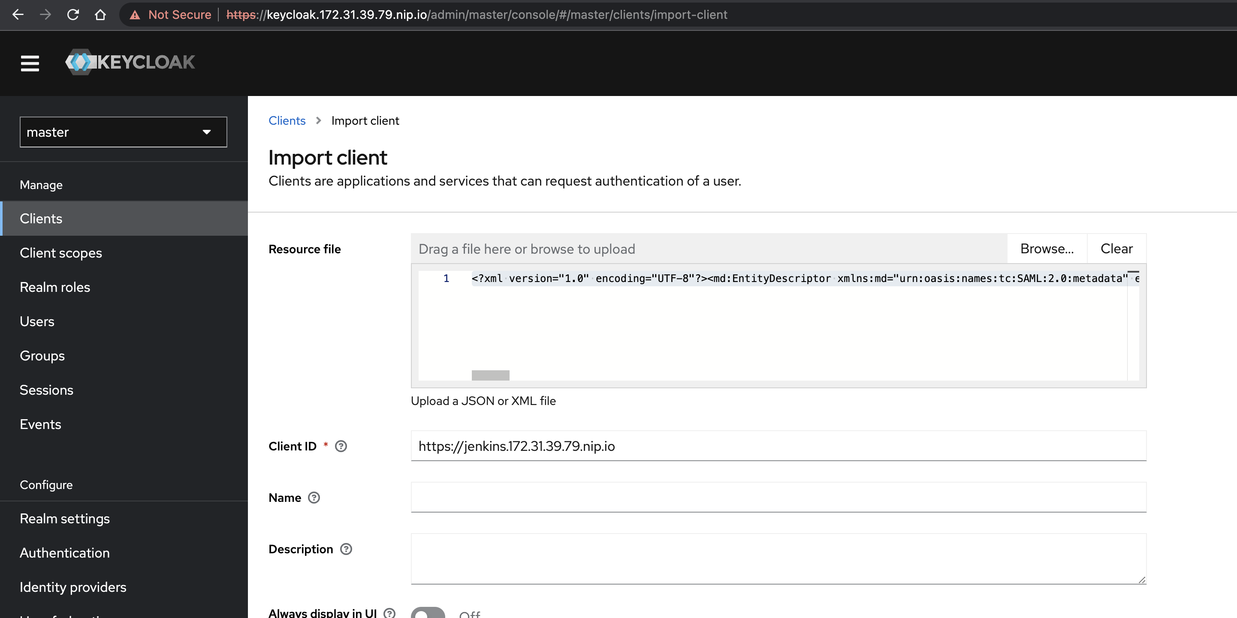

**https://keycloak.172.31.39.79.nip.io/realms/master/protocol/saml/descriptor**

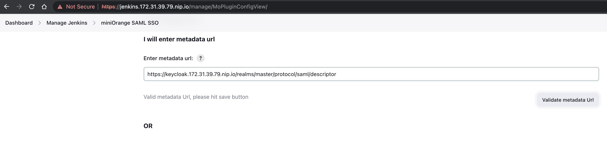

Click Save

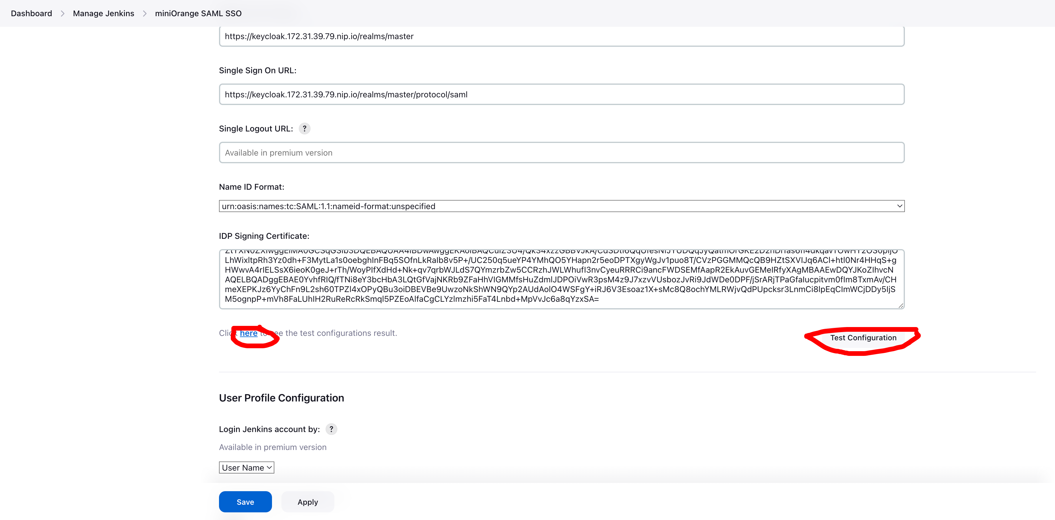

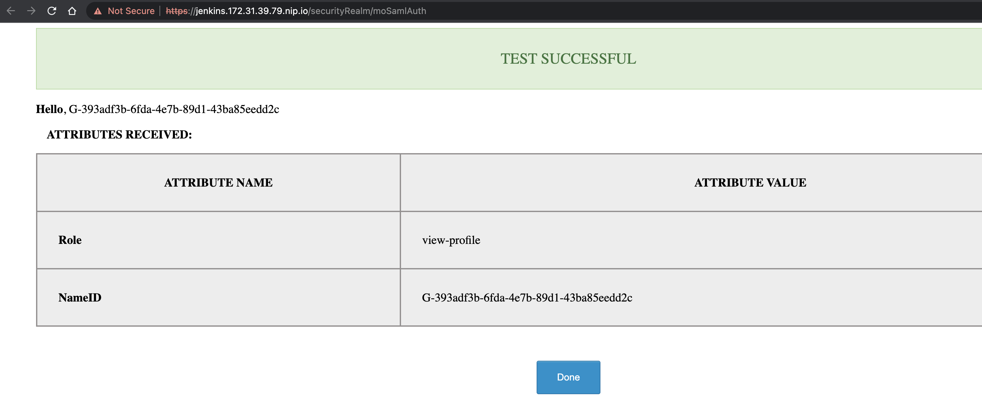

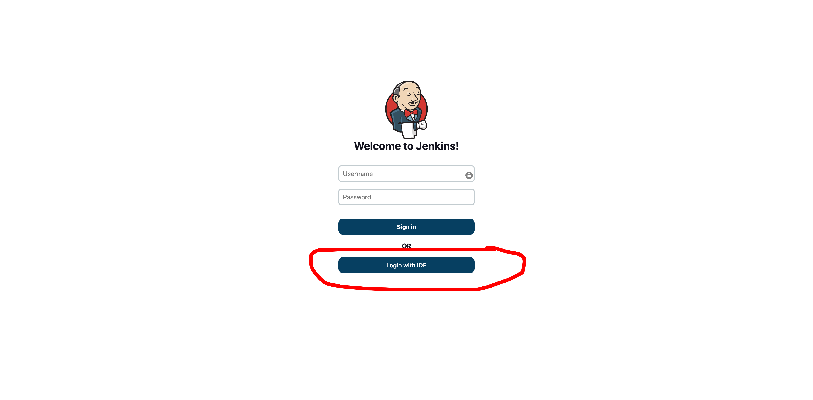

**Sample Application 2:**

Install Nginx:

* vi nginx.yaml
* kubectl create -f nginx.yaml
* We need to update the client id ,nginx ip and secret it. Highlighted the fields below

apiVersion: apps/v1

kind: Deployment

metadata:

name: nginx

namespace: default

spec:

replicas: 1

selector:

matchLabels:

app: nginx

template:

metadata:

labels:

app: nginx

spec:

containers:

- name: nginx

image: nginx

- name: gatekeeper

image: carlosedp/keycloak-gatekeeper:latest

args:

- --config=/etc/keycloak-gatekeeper.conf

ports:

- containerPort: 3000

name: service

volumeMounts:

- name: gatekeeper-config

mountPath: /etc/keycloak-gatekeeper.conf

subPath: keycloak-gatekeeper.conf

- name: gatekeeper-files

mountPath: /html

volumes:

- name : gatekeeper-config

configMap:

name: gatekeeper-config

- name : gatekeeper-files

configMap:

name: gatekeeper-files

---

apiVersion: v1

kind: ConfigMap

metadata:

name: gatekeeper-config

namespace: default

creationTimestamp: null

data:

keycloak-gatekeeper.conf: |+

# is the url for retrieve the OpenID configuration - normally the <server>/auth/realms/<realm_name>

discovery-url: https://keycloak.172.31.35.75.nip.io/realms/master

# skip tls verify

skip-openid-provider-tls-verify: true

# the client id for the 'client' application

client-id: gatekeeper

# the secret associated to the 'client' application

client-secret: Wi4Wh16UbPaGqhRAnhsvQSNV34jWDfKI

# the interface definition you wish the proxy to listen, all interfaces is specified as ':<port>', unix sockets as unix://<REL_PATH>|</ABS PATH>

listen: :3000

# whether to enable refresh tokens

enable-refresh-tokens: true

# the location of a certificate you wish the proxy to use for TLS support

tls-cert:

# the location of a private key for TLS

tls-private-key:

# the redirection url, essentially the site url, note: /oauth/callback is added at the end

redirection-url: http://nginx.172.31.35.75.nip.io

secure-cookie: false

# the encryption key used to encode the session state

encryption-key: vGcLt8ZUdPX5fXhtLZaPHZkGWHZrT6aa

# the upstream endpoint which we should proxy request

upstream-url: http://127.0.0.1:80/

forbidden-page: /html/access-forbidden.html

resources:

- uri: /*

groups:

- my-app

---

apiVersion: v1

kind: ConfigMap

metadata:

name: gatekeeper-files

namespace: default

creationTimestamp: null

data:

access-forbidden.html: |+

<html lang="en"><head> <title>Access Forbidden</title><style>*{font-family: "Courier", "Courier New", "sans-serif"; margin:0; padding: 0;}body{background: #233142;}.whistle{width: 20%; fill: #f95959; margin: 100px 40%; text-align: left; transform: translate(-50%, -50%); transform: rotate(0); transform-origin: 80% 30%; animation: wiggle .2s infinite;}@keyframes wiggle{0%{transform: rotate(3deg);}50%{transform: rotate(0deg);}100%{transform: rotate(3deg);}}h1{margin-top: -100px; margin-bottom: 20px; color: #facf5a; text-align: center; font-size: 90px; font-weight: 800;}h2, a{color: #455d7a; text-align: center; font-size: 30px; text-transform: uppercase;}</style> </head><body> <use> <svg version="1.1" xmlns="http://www.w3.org/2000/svg" xmlns:xlink="http://www.w3.org/1999/xlink" x="0px" y="0px" viewBox="0 0 1000 1000" enable-background="new 0 0 1000 1000" xml:space="preserve" class="whistle"><g><g transform="translate(0.000000,511.000000) scale(0.100000,-0.100000)"><path d="M4295.8,3963.2c-113-57.4-122.5-107.2-116.8-622.3l5.7-461.4l63.2-55.5c72.8-65.1,178.1-74.7,250.8-24.9c86.2,61.3,97.6,128.3,97.6,584c0,474.8-11.5,526.5-124.5,580.1C4393.4,4001.5,4372.4,4001.5,4295.8,3963.2z"/><path d="M3053.1,3134.2c-68.9-42.1-111-143.6-93.8-216.4c7.7-26.8,216.4-250.8,476.8-509.3c417.4-417.4,469.1-463.4,526.5-463.4c128.3,0,212.5,88.1,212.5,224c0,67-26.8,97.6-434.6,509.3c-241.2,241.2-459.5,449.9-488.2,465.3C3181.4,3180.1,3124,3178.2,3053.1,3134.2z"/><path d="M2653,1529.7C1644,1445.4,765.1,850,345.8-32.7C62.4-628.2,22.2-1317.4,234.8-1960.8C451.1-2621.3,947-3186.2,1584.6-3500.2c1018.6-501.6,2228.7-296.8,3040.5,515.1c317.8,317.8,561,723.7,670.1,1120.1c101.5,369.5,158.9,455.7,360,553.3c114.9,57.4,170.4,65.1,1487.7,229.8c752.5,93.8,1392,181.9,1420.7,193.4C8628.7-857.9,9900,1250.1,9900,1328.6c0,84.3-67,172.3-147.4,195.3c-51.7,15.3-790.8,19.1-2558,15.3l-2487.2-5.7l-55.5-63.2l-55.5-61.3v-344.6V719.8h-411.7h-411.7v325.5c0,509.3,11.5,499.7-616.5,494C2921,1537.3,2695.1,1533.5,2653,1529.7z"/></g></g></svg></use><h1>403</h1><h2>Not this time, access forbidden!</h2><h2><a href="/oauth/logout?redirect=https://google.com">Logout</h2></body></html>

---

apiVersion: v1

kind: Service

metadata:

labels:

app: nginx

name: nginx

namespace: default

spec:

ports:

- name: http

port: 80

protocol: TCP

targetPort: service

selector:

app: nginx

type: ClusterIP

---

apiVersion: networking.k8s.io/v1beta1

kind: Ingress

metadata:

name: nginx

namespace: default

annotations:

nginx.ingress.kubernetes.io/rewrite-target: /

spec:

rules:

- host: nginx.172.31.35.75.nip.io

http:

paths:

- path: /

backend:

serviceName: nginx

servicePort: 80

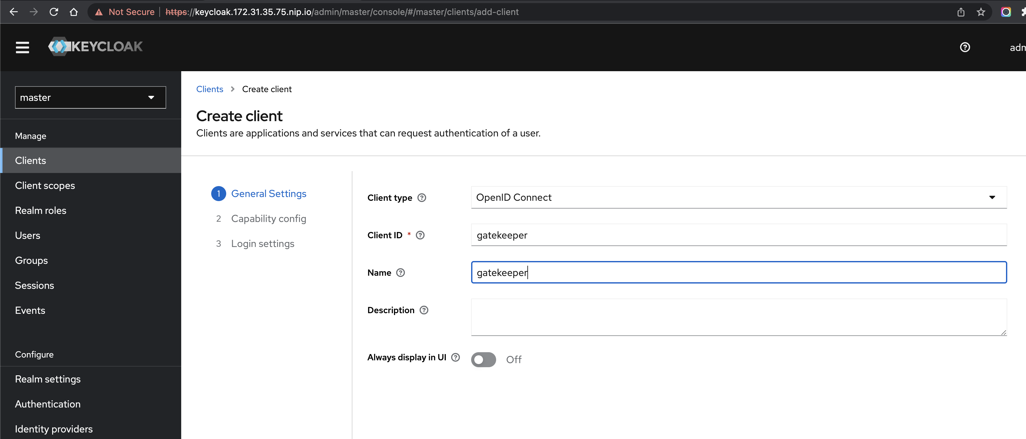

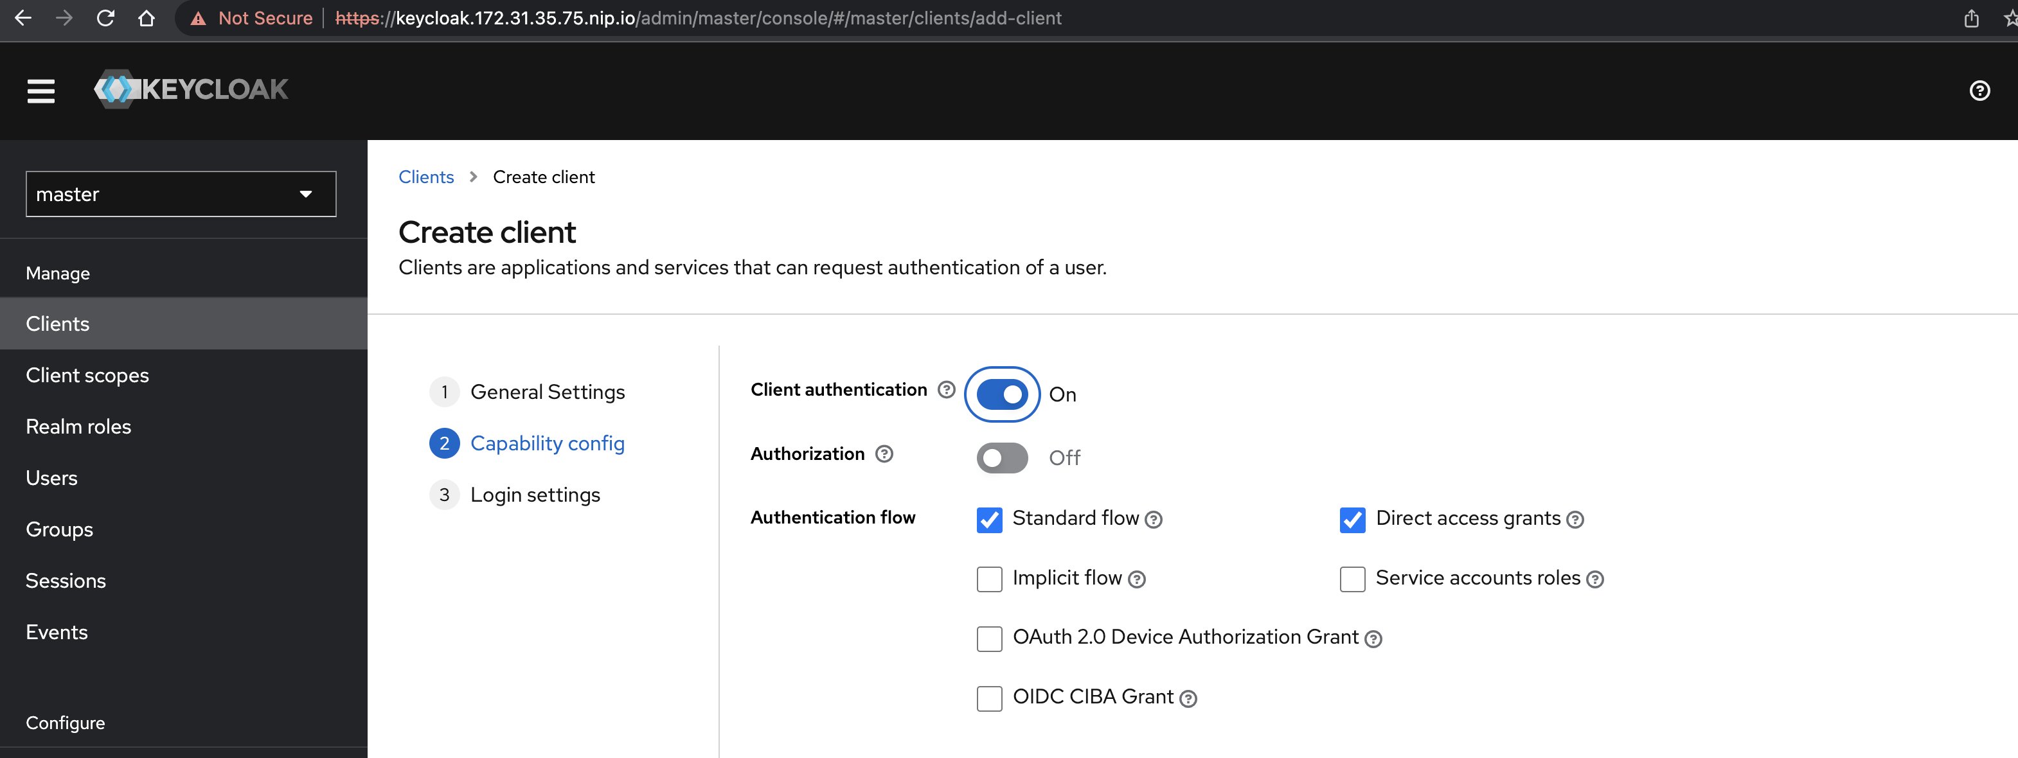

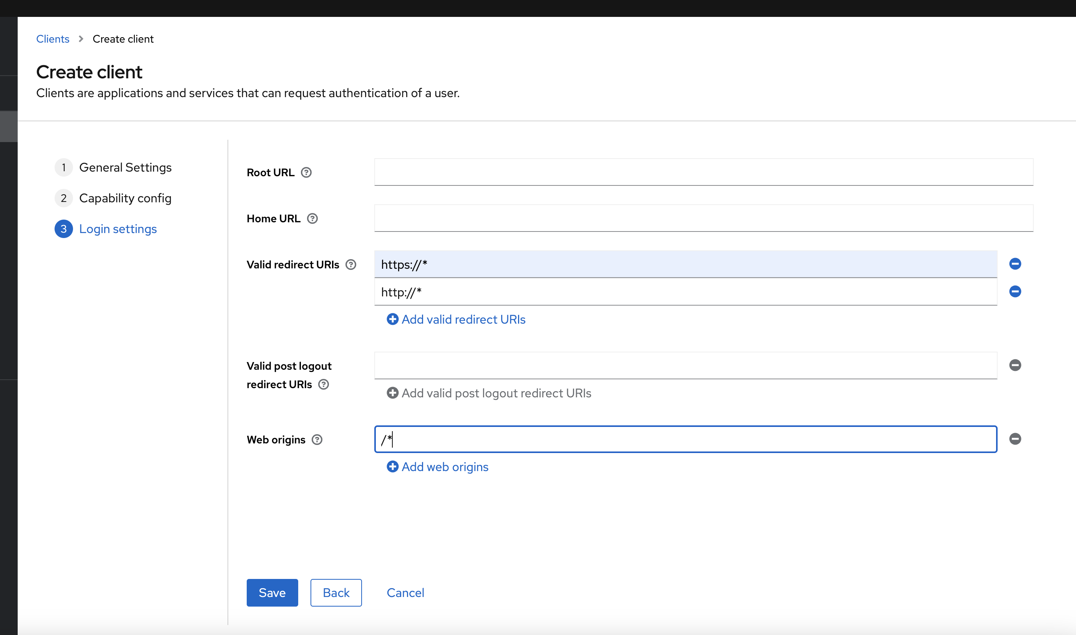

Click on Save and revalidate the settings.

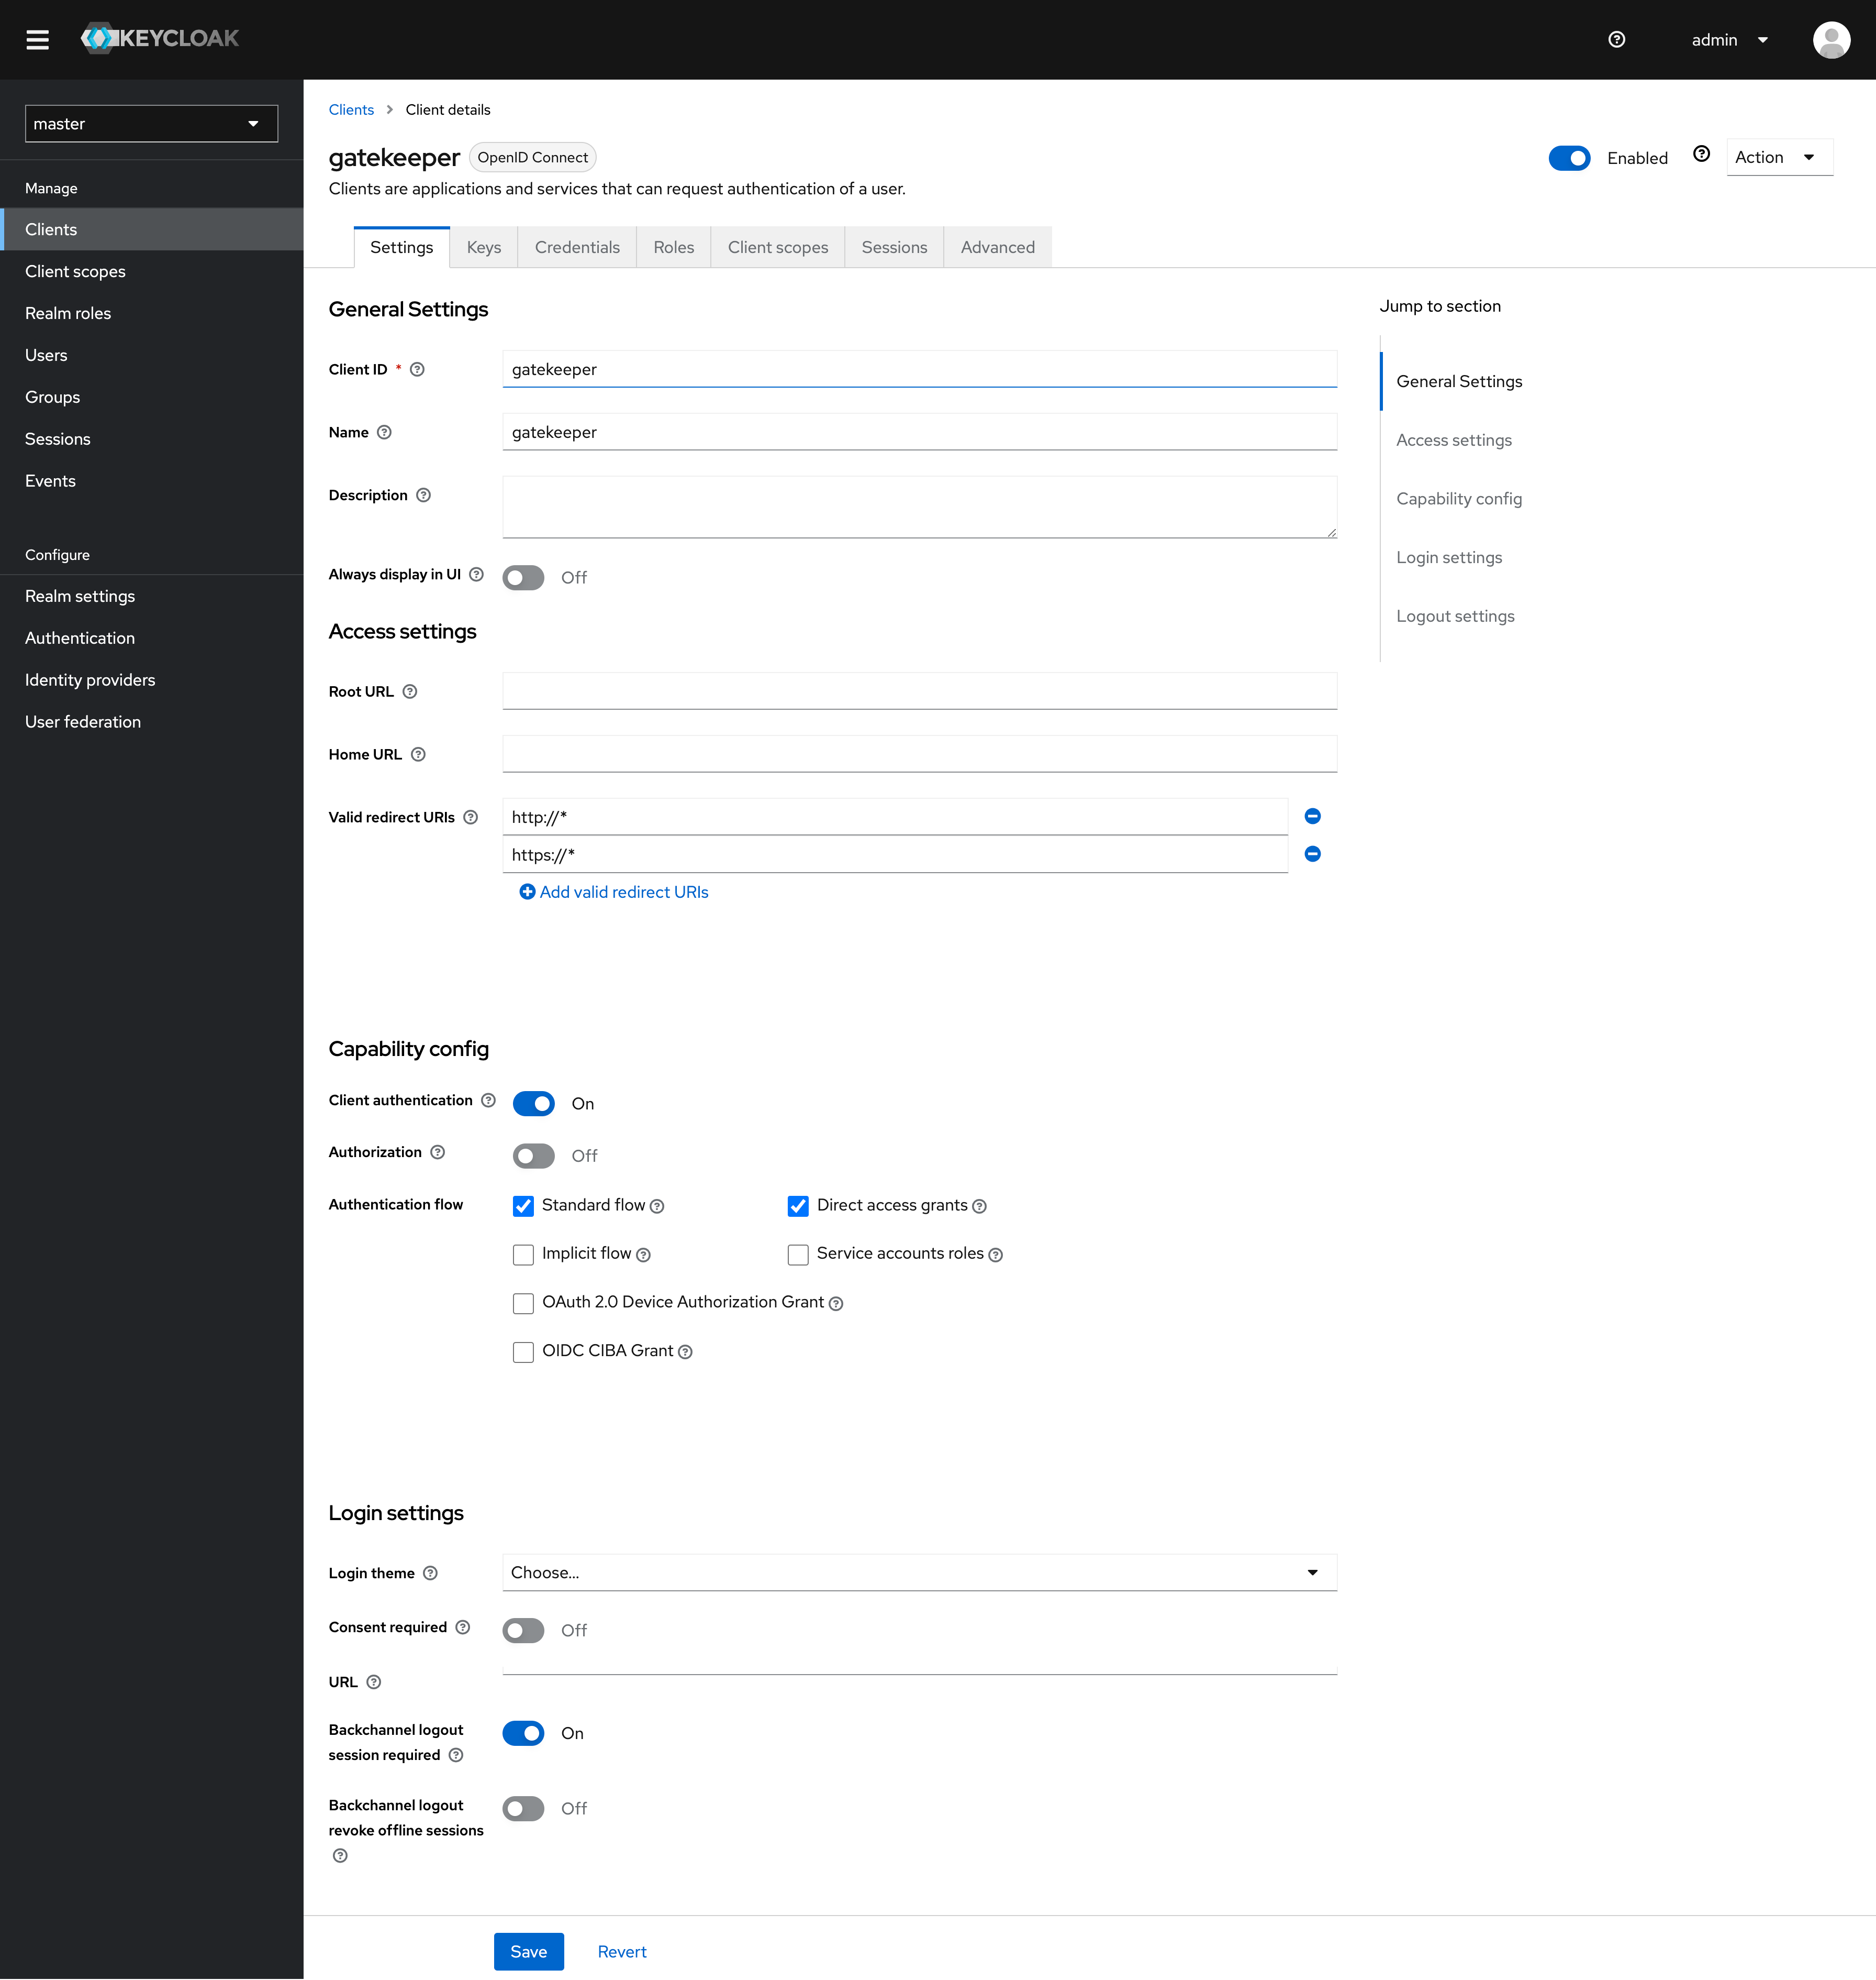

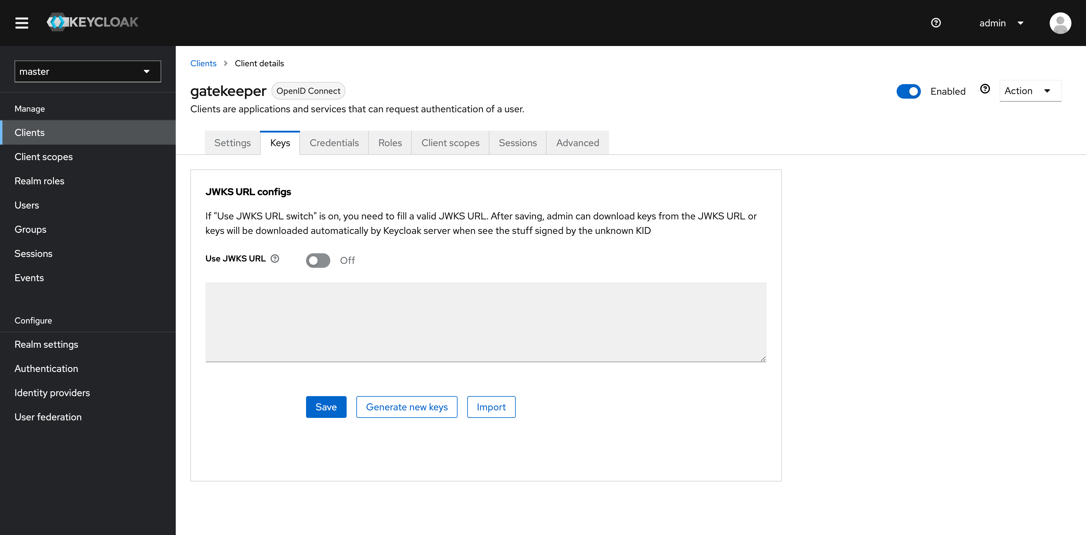

Update the client secret in nginx.yaml

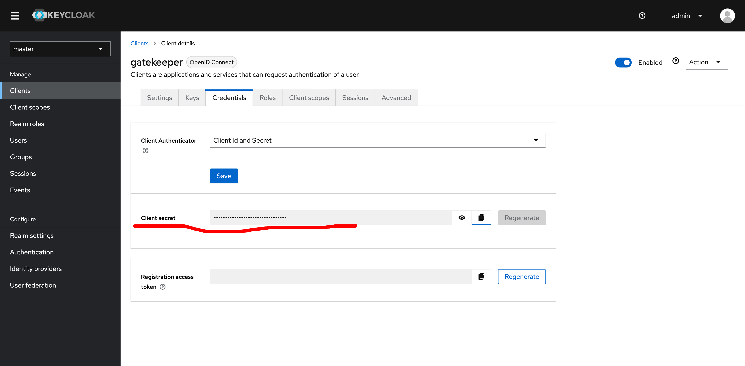

Click on [gatekeeper-dedicated](https://keycloak.172.31.35.75.nip.io/admin/master/console/#/master/clients/b24349a3-beba-4e89-bd37-121f5951475c/clientScopes/dedicated)

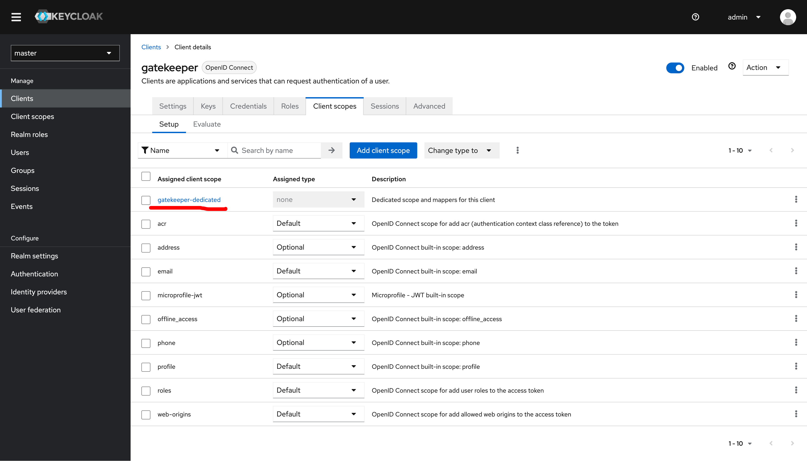

Click on configure new mapper

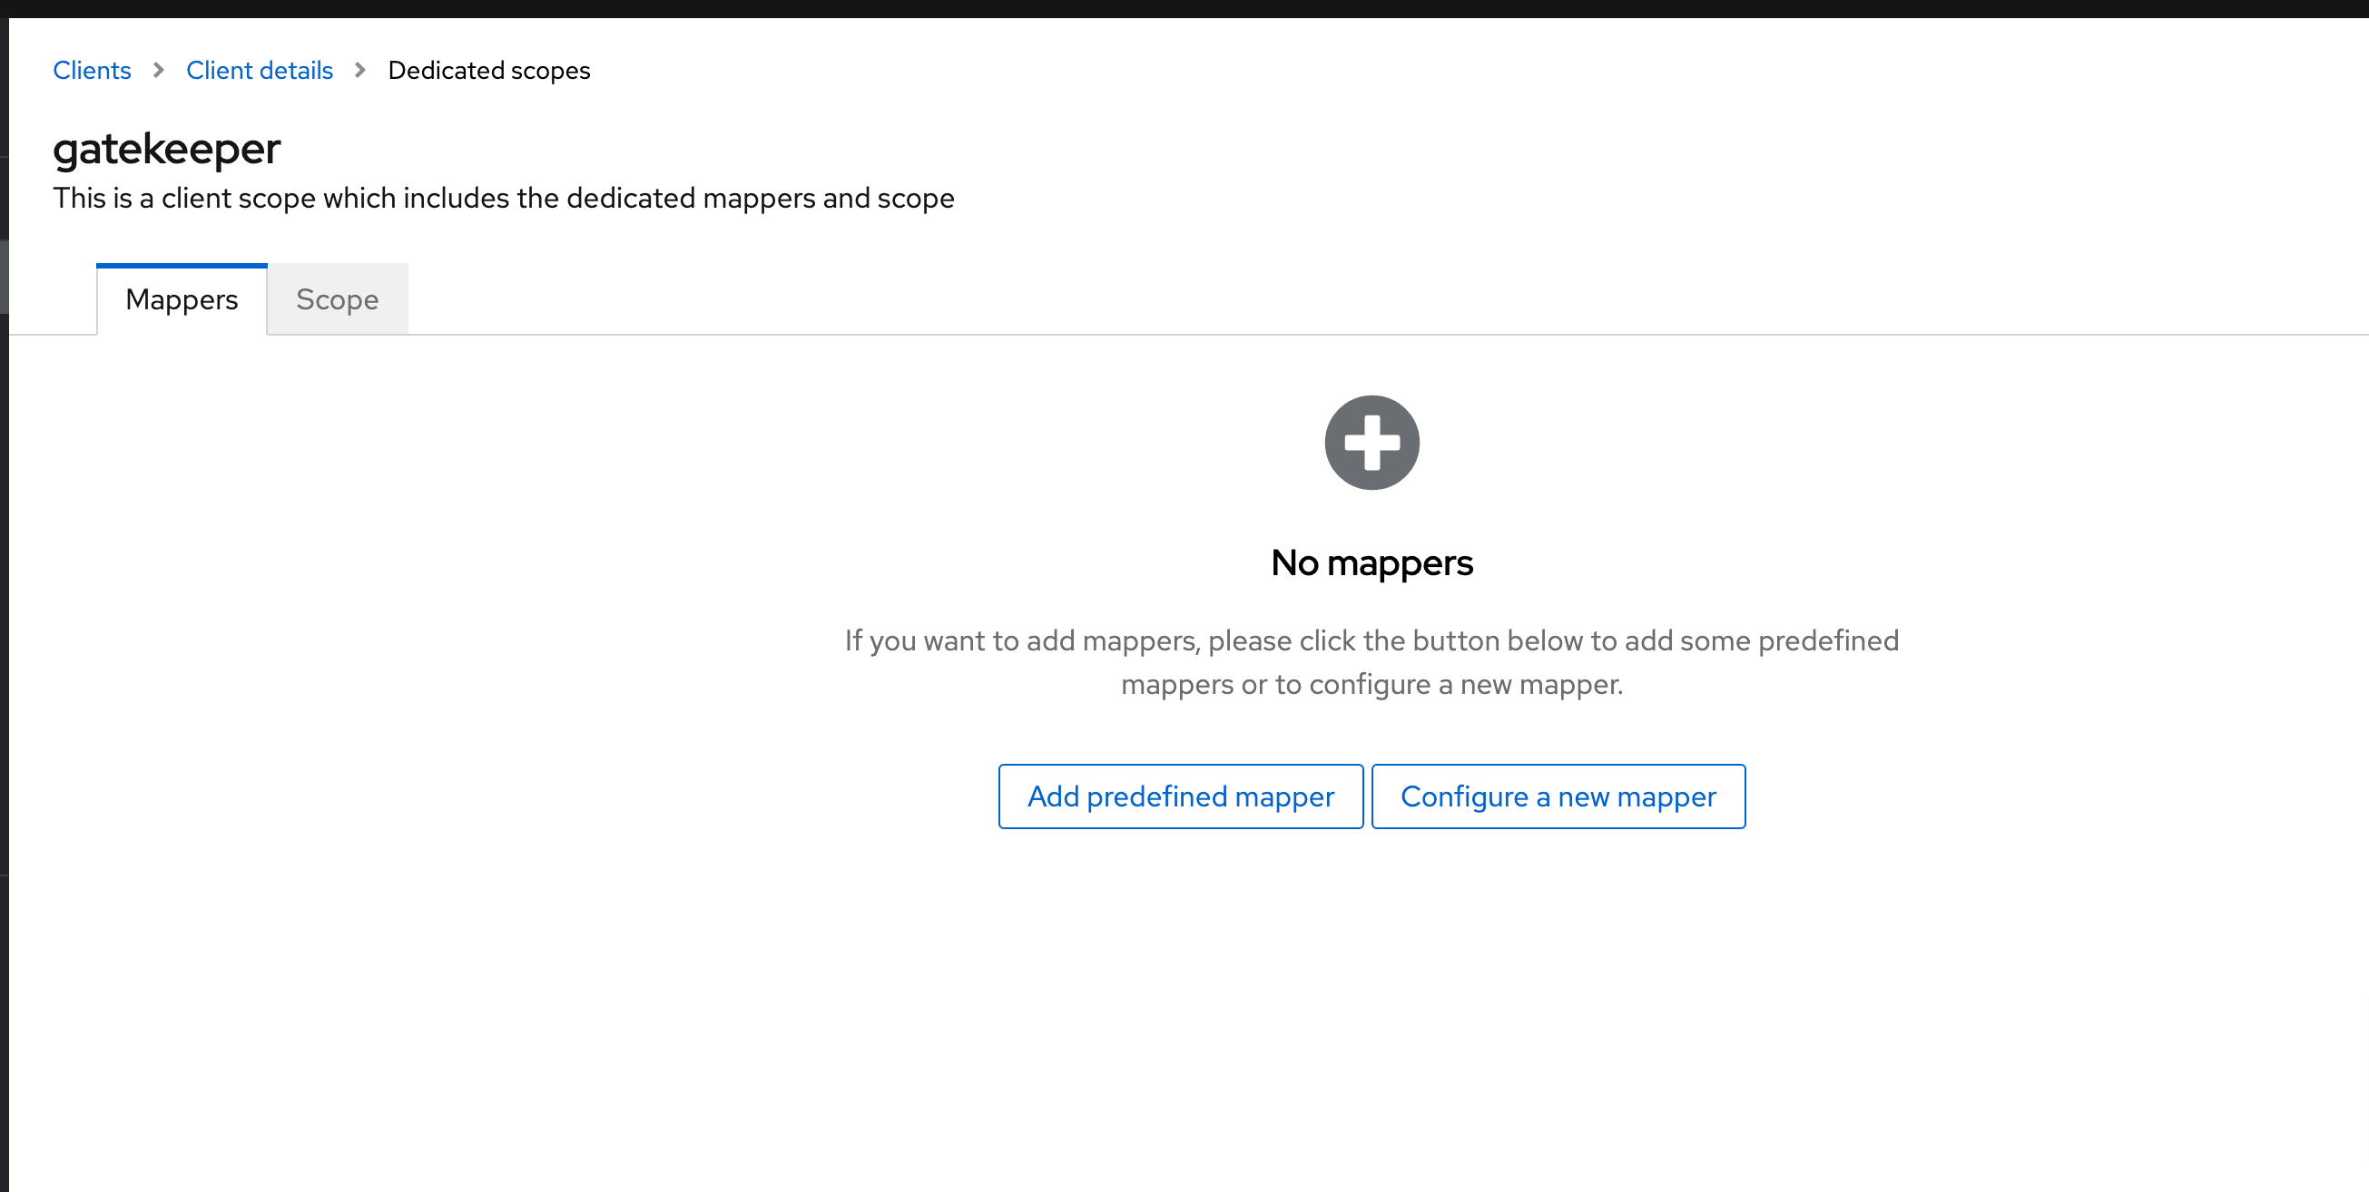

Select Audience

Not properly

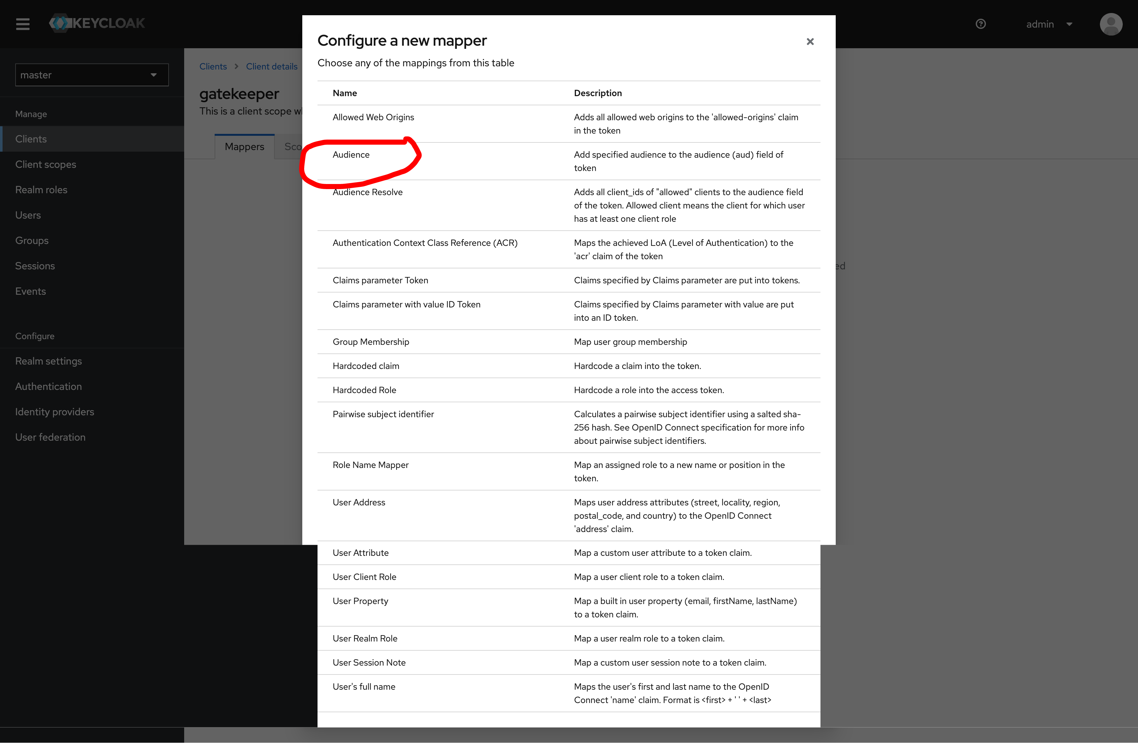

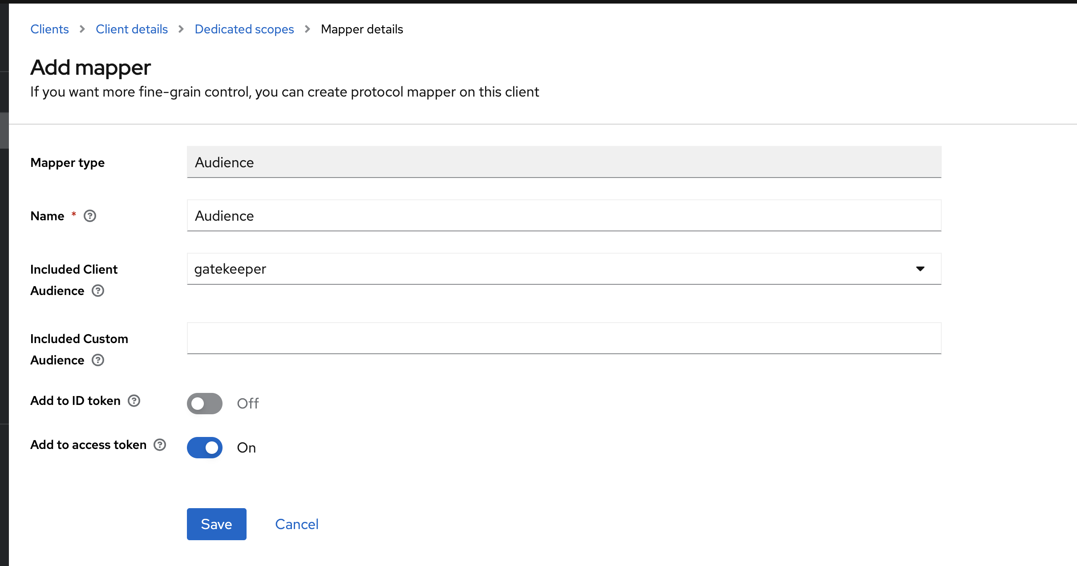

Click on save

Create new mapper

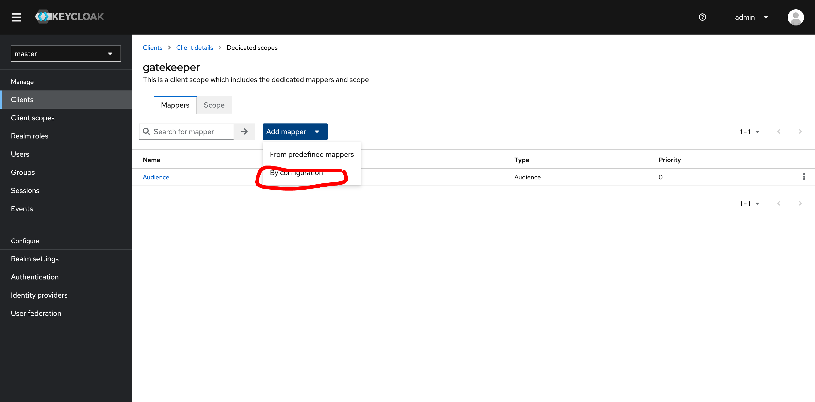

Select Group membership

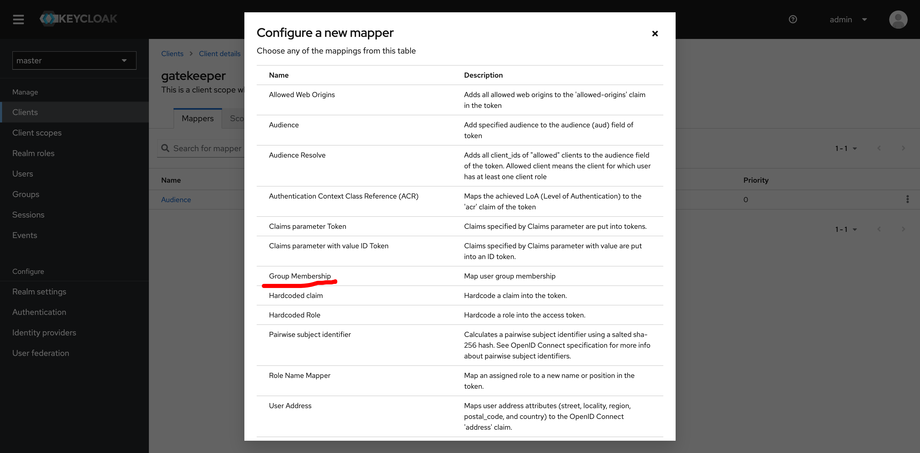

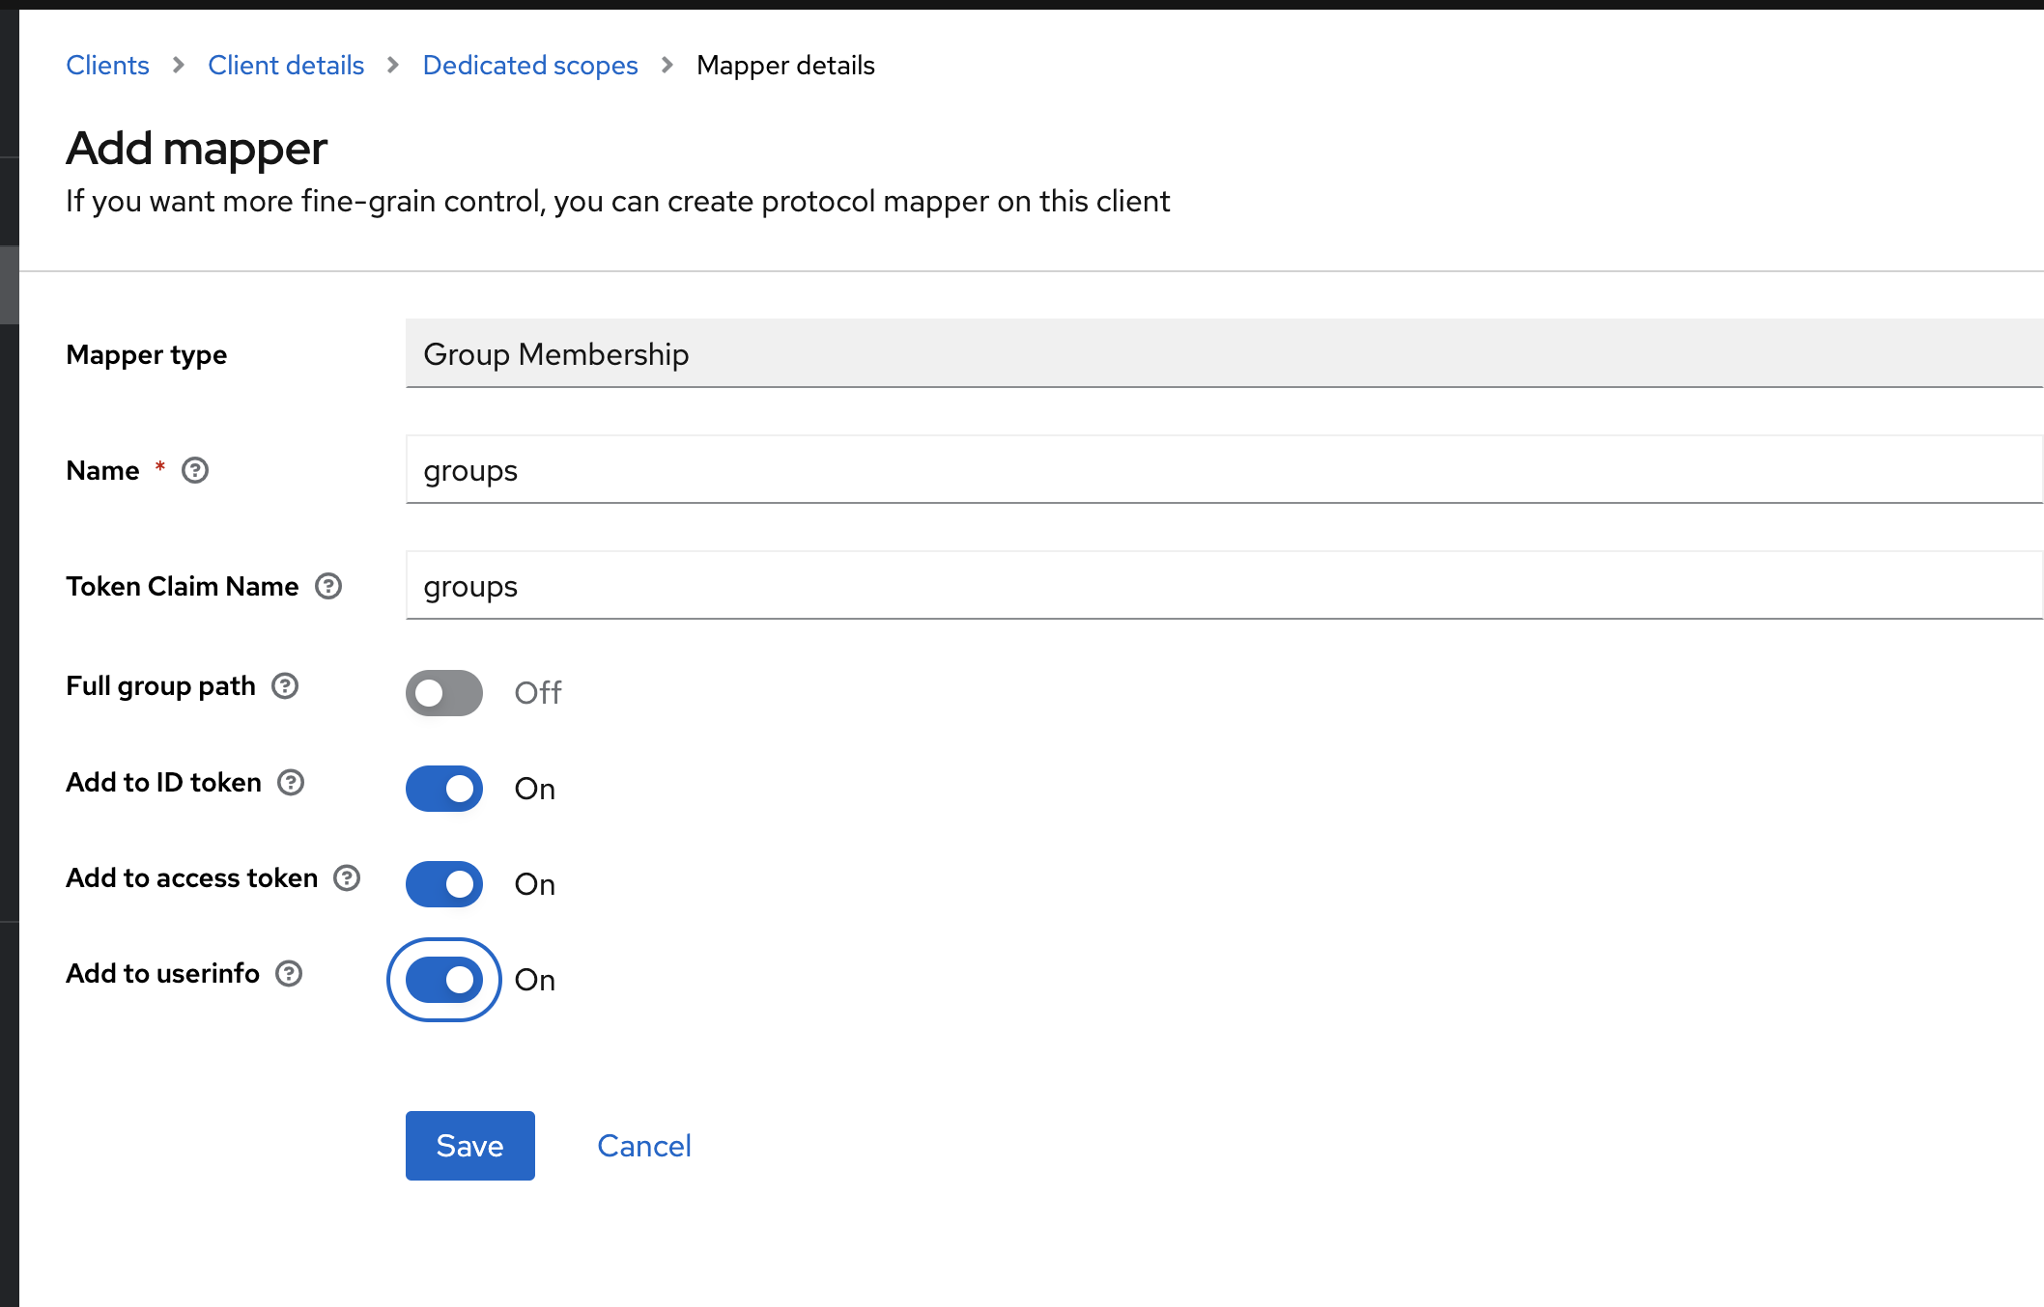

Create user click on save

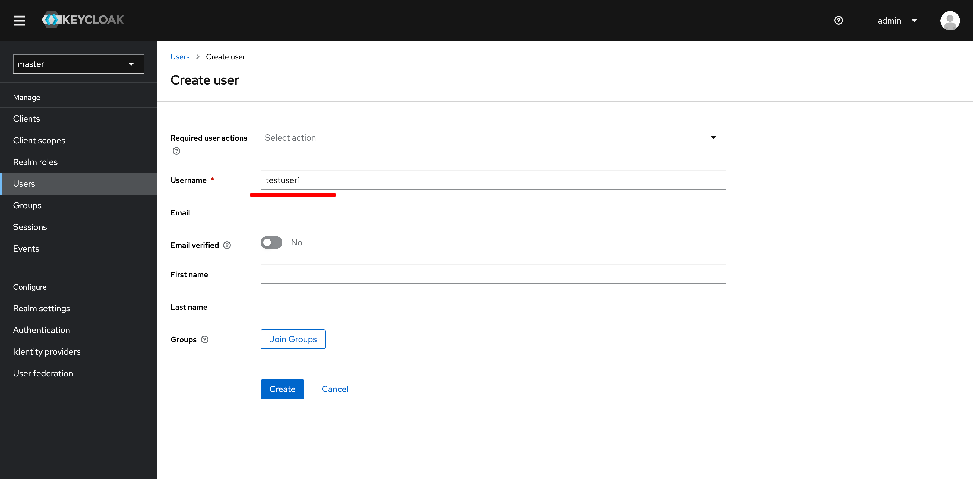

Once user saved go to credentials

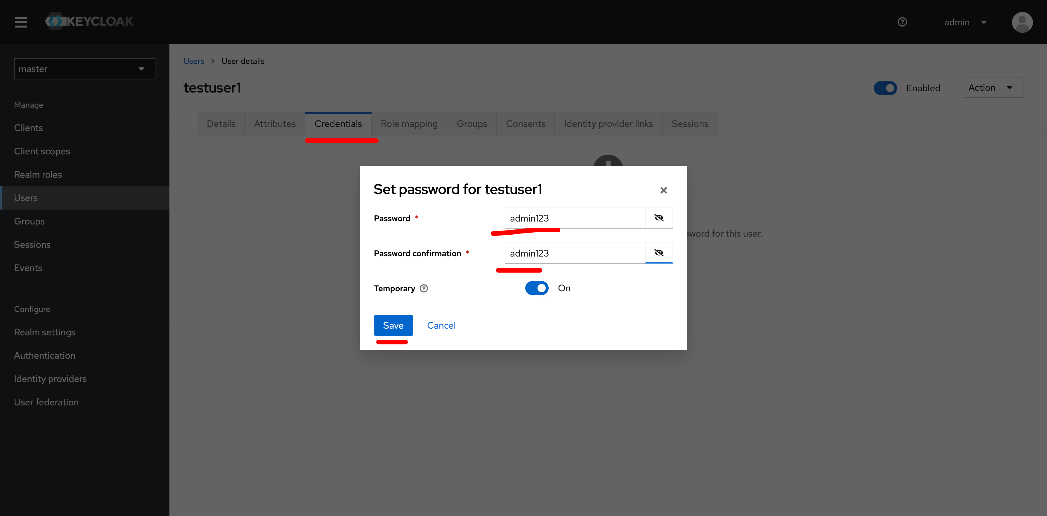

Create group

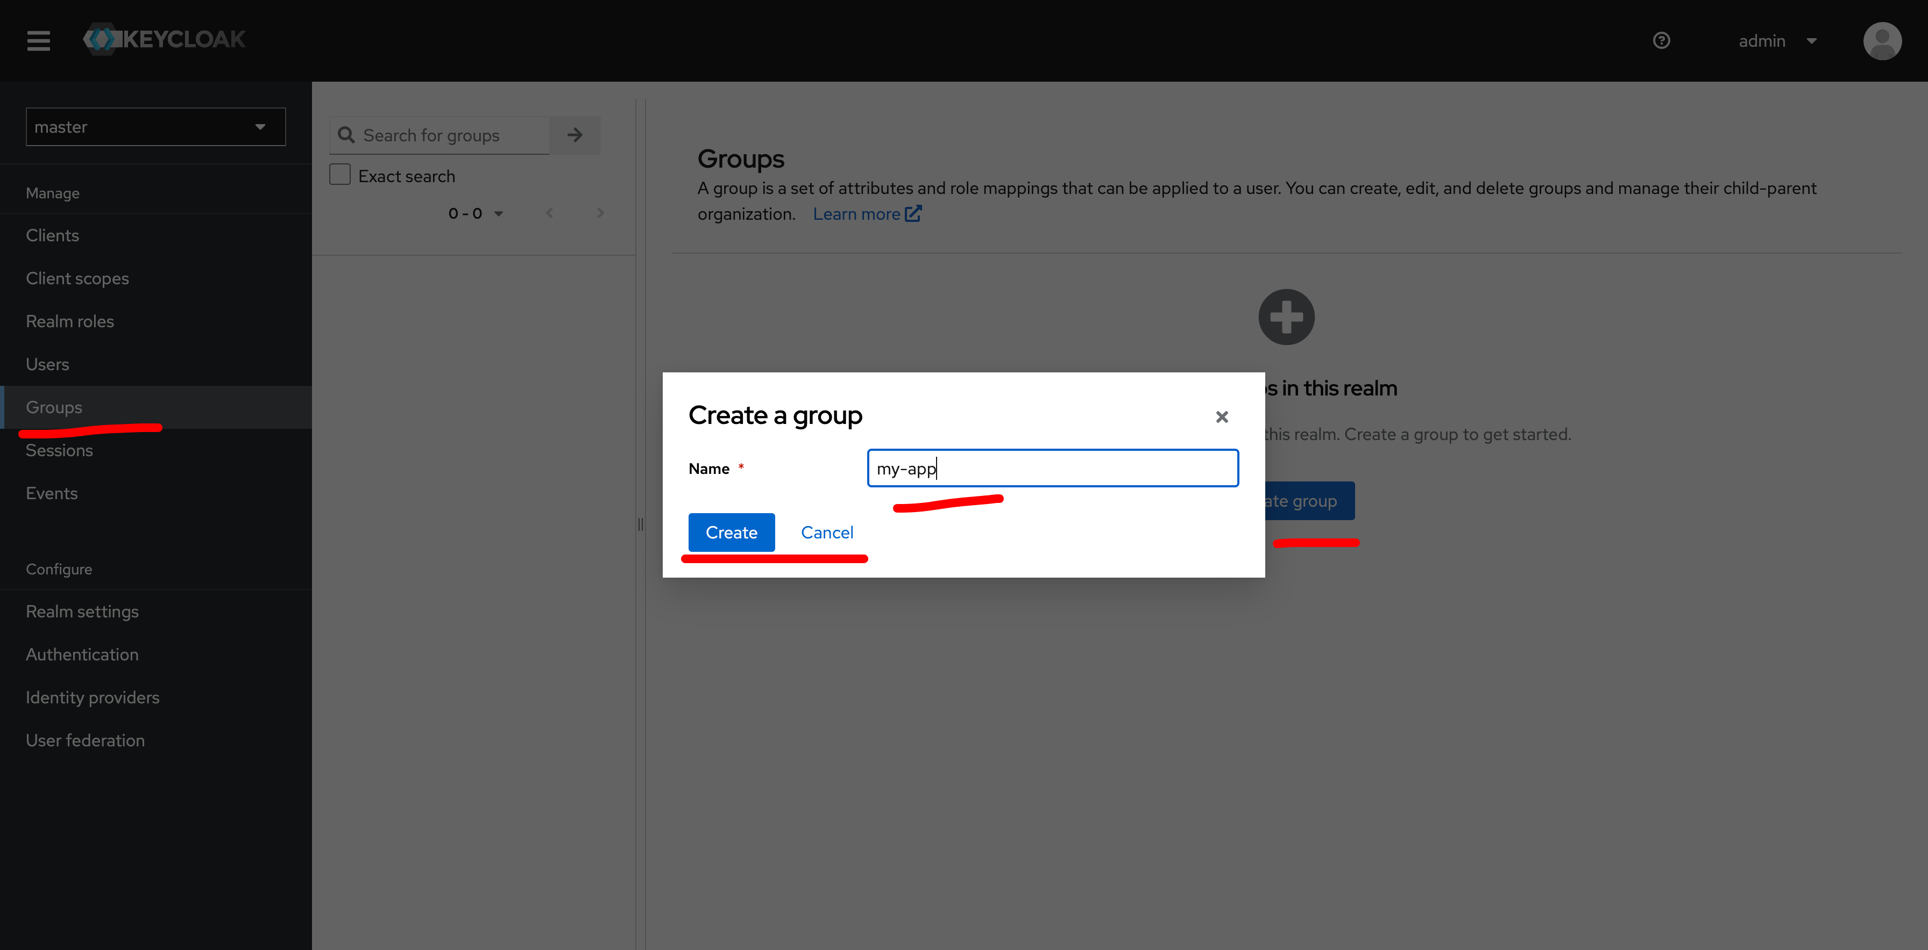

Add testuser1 to myapp group

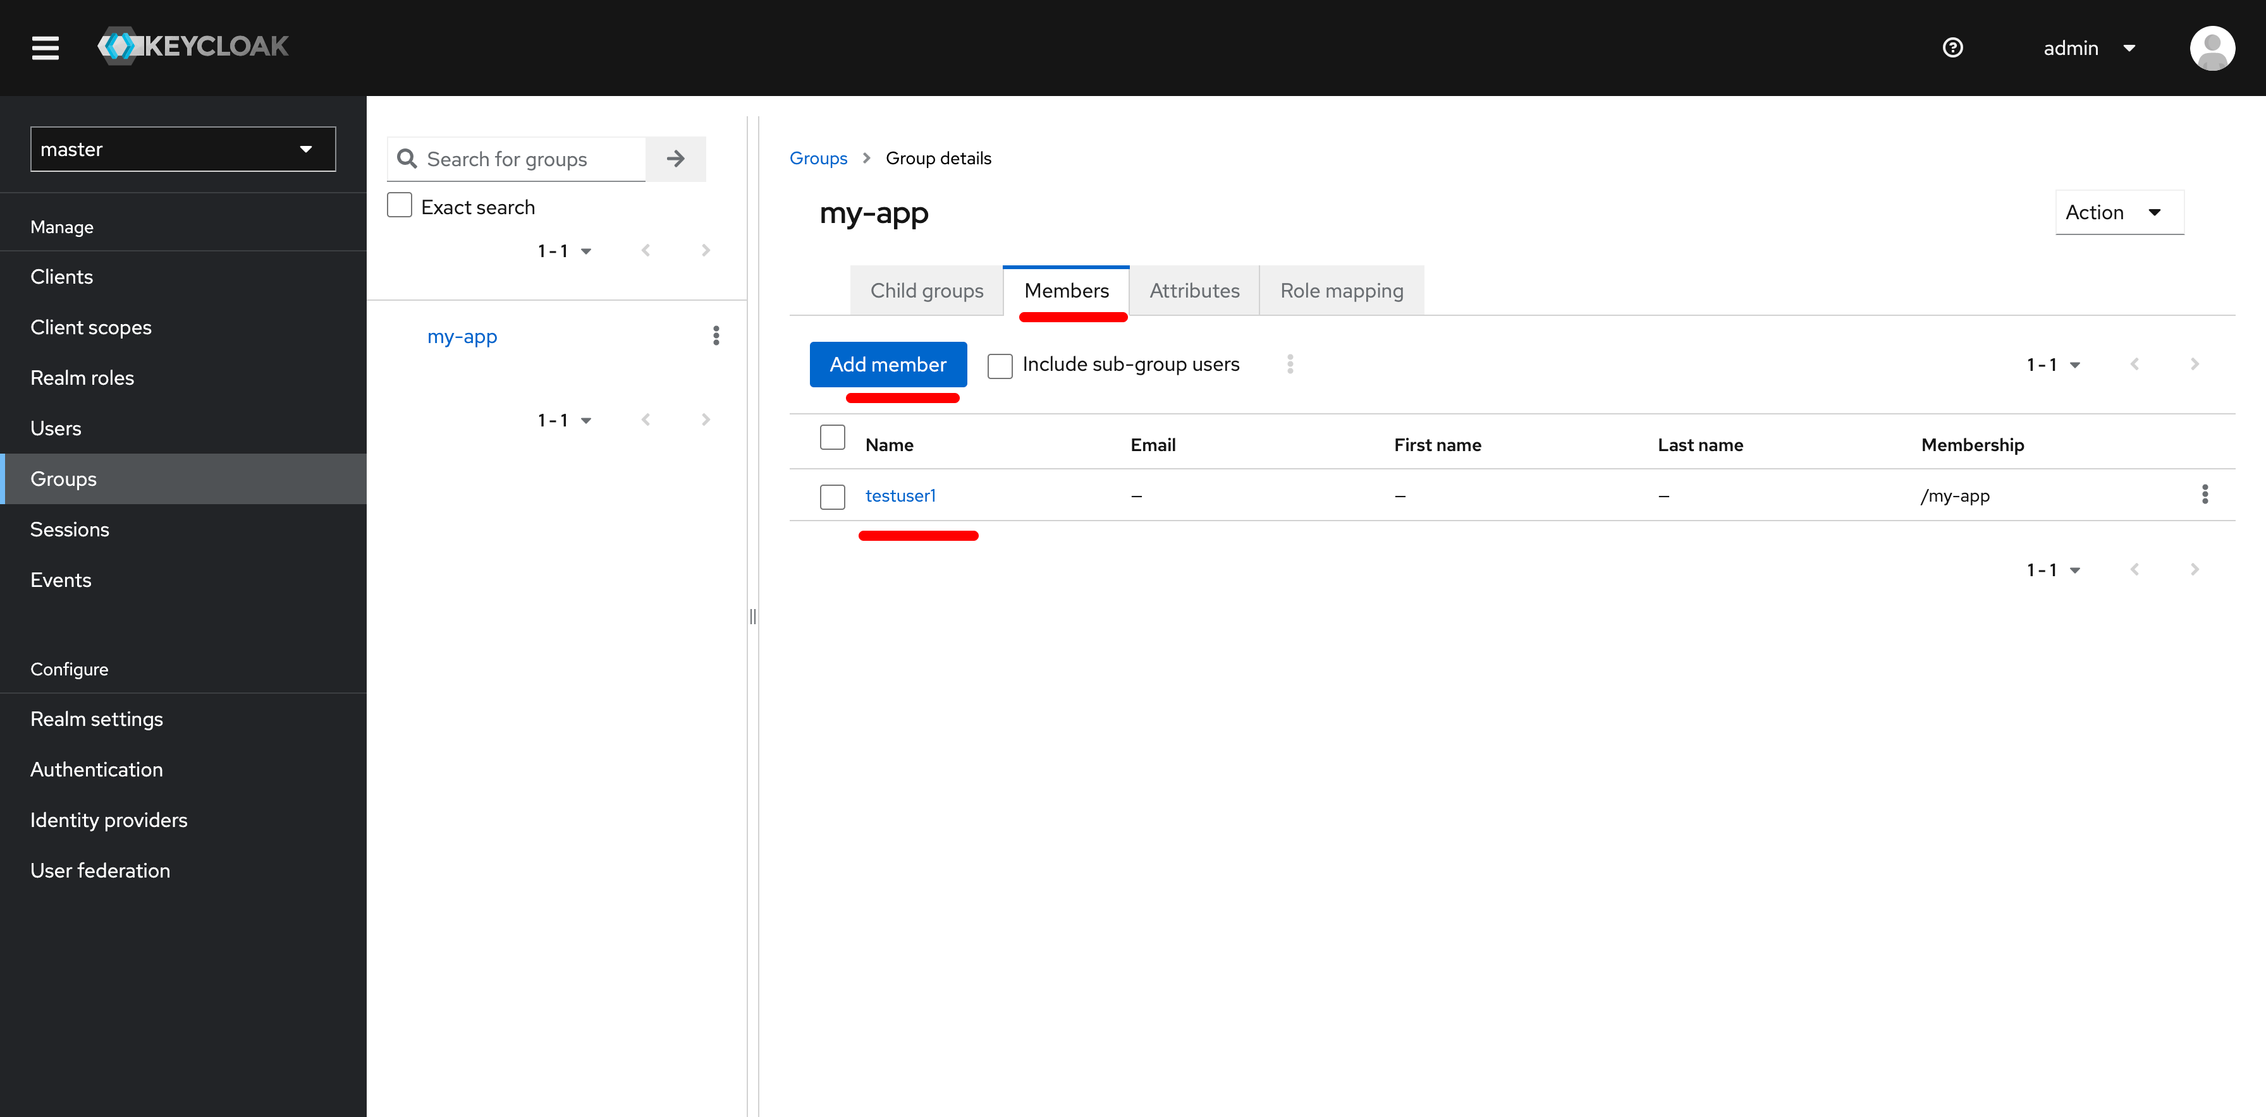

Once done access nginx page

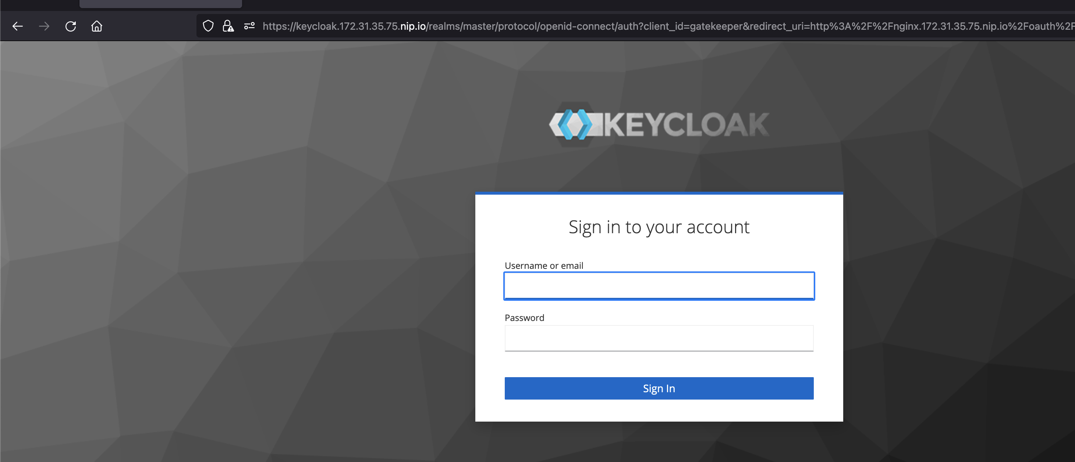

It will redirect to keycloak page now enter testuser1 login details and password.

It will ask you to update new credentials.

